**Tiananmen Square**

**RULES:** Practical Shooting Handbook, Latest Edition **COURSE DESIGNER:** Ike Starnes

|  |  |
| --- | --- |
| **START POSITION: See written stage briefings.** | |
| **STAGE PROCEDURE**  Engage targets from within the shooting area. | **SCORING**  **SCORING:** Comstock 19 rounds.  **TARGETS:** Some cardboard, some rubber  **SCORED HITS:** 2 Best hits per carboard will be scored, rubber must fall to score.  **START-STOP:**  Audible - Last shot  **PENALTIES:** Mike -10, NS -10, Procedural -10 |

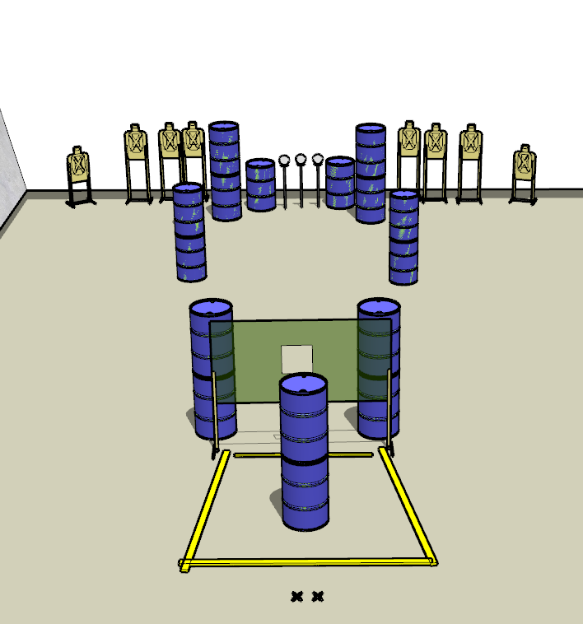

**Written Stage Briefings:**

**Stage 1 –** is a 19-round, 95 point, Comstock Long Course. There are 8 cardboard targets and 3 rubber targets. The best 2 hits per cardboard target will be scored. The rubber targets must fall to score.

**Handgun start position** is standing with both feet on the Xs with wrists below belt. The handgun is **unloaded** and holstered.

**PCC start position** is standing with both feet on the Xs. PCC is **unloaded** with buttstock on belt with muzzle pointed downrange.

On the audible start signal, engage targets from within the shooting area. **You must make a mandatory reload before your final shot is fired.**

**Stage 2 –** is a 19-round, 95 point, Comstock Long Course. There are 8 cardboard targets and 3 rubber targets. The best 2 hits per cardboard target will be scored. The rubber targets must fall to score.

**Handgun start position** is standing with both feet on the Xs with wrists below belt. The handgun is loaded and holstered.

**PCC start position** is standing with both feet on the Xs. PCC is loaded with safety on and buttstock on belt with muzzle pointed downrange.

On the audible start signal, engage targets from within the shooting area. **The last 6 scoring shots must be fired strong hand / strong shoulder only.**

**Stage 3 –** is a 19-round, 95 point, Comstock Long Course. There are 8 cardboard targets and 3 rubber targets. The best 2 hits per cardboard target will be scored. The rubber targets must fall to score.

**Handgun start position** is standing with both feet on the Xs with wrists below belt. The handgun is loaded and holstered.

**PCC start position** is standing with both feet on the Xs. PCC is loaded with safety on and buttstock on belt with muzzle pointed downrange.

On the audible start signal, engage targets from within the shooting area. **The last 6 scoring shots must be fired weak hand / weak shoulder only.**